*Program for “Sentiments Analysis”*

As we read before that in social media people shows their all kinds of sentiments through their posts, comments, emoticons, emojis etc. Their sentiments could be positive; it could be negative as well as neutral. We have to determine those sentiments whether is it positive or is it negative or is it neutral, and here we are doing it with the help of a program.

Our objective here is to determine the sentiment of the person. We will do it with the help of the comment he post in the social media. We will take his or her comment as an input and with the help of our program we will get to know whether his comment is positive, negative or neutral.

Technology which we are using here is Python to make our program.

***Algorithm of our program-***

Firstly we will create a variable named as ‘chat’.

Then we will take an input from user as a string which will be his comment on any particular post.

We will assign that input string to our previously defined variable ‘chat’.

We will convert the whole string into lower case and then split every word in the string separately.

Then we will create three lists named as Positive[], Negative[], and Neutral[].

We store some used positive keyword in our Positive[] list.

Then we will store some frequently used negative keywords in our Negative[] .

Also do the same with the Neutral[] list and store some frequently neutral used keywords in it.

Then we will create a for loop in which with the help of a variable we will traverse that particular variable in our positive list.

Same we will do with the other two lists also, we will iterate a for loop in other two lists also.

Then we will apply a condition in all the loops separately to find the keyword, and check what keywords are present in that string which will we take as input from the user his comment.

Then after we will check that what types of keywords present in that string which was given as an input from the user whether they are positive, negative or neutral.

We will do this to all the three different for loop we created to check whether the given comment is positive, negative or neutral.

Here we have also used Matplotlib for the visualization of the data.

With the help of matplotlib we have represented the percentages of the different sentiments in the pie chart as well as bar chart.

And at last we will get the result of the sentiments in that particular comment.

Here we have also used a counter with every loop to check that what percent of sentiments of each type present in that comment.

At last we will get our desired result and in it we will get to know that which type of sentiments the person is showing in his comment.

We will also get to know the percentage of which sentiment is present in that comment.

Like this our whole program will run and give us our desired result as an output with simple visualization.

***###Here is the program-***

--Initialization of script and scanning the user input--

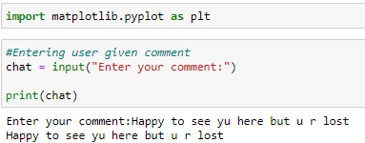

--Preprocessing of the scanned data--

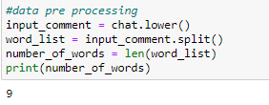

--List creation of keywords of different sentiments--

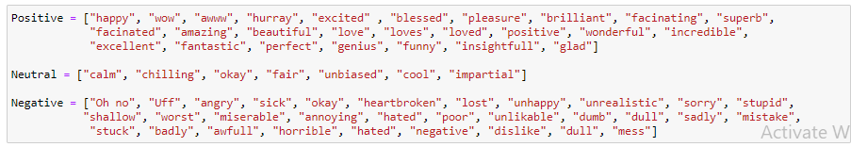

--Creating loop to check positivity in the data--

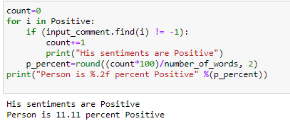

--Creating loop to check neutrality in the dat--

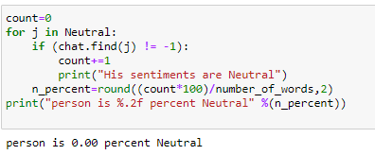

--Creating loop to check the negativity in the data --

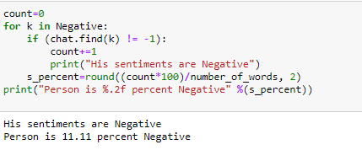

--Checking remaining data --

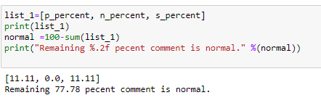

--Visualization of our Result through Pie Chart--

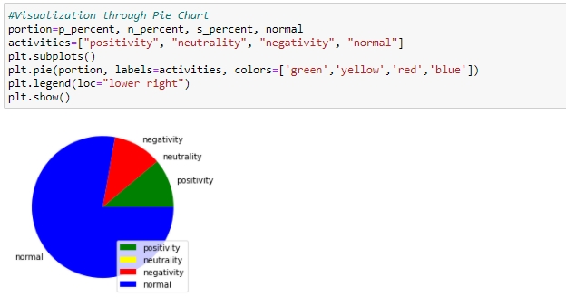

--Visualization of our Result through Bar Graph --

